Script Used:
#Name: Jonnathan MacKinnon
#Course: CPT201 - Week 1: Activity 2

Write-Output " Name: Jonnathan MacKinnon"
Write-Output "PowerShell Week1 Script for basic automation scripts and security checks"

#Display current date and time
Get-Date

#List running processes
Get-Process | Select-Object -First 3

#List running services
Get-Service | Select-Object -First 3

#Use pipeline to sort the processes by their CPU usage
Get-process | Sort-Object CPU -Descending | Select-Object -First 3
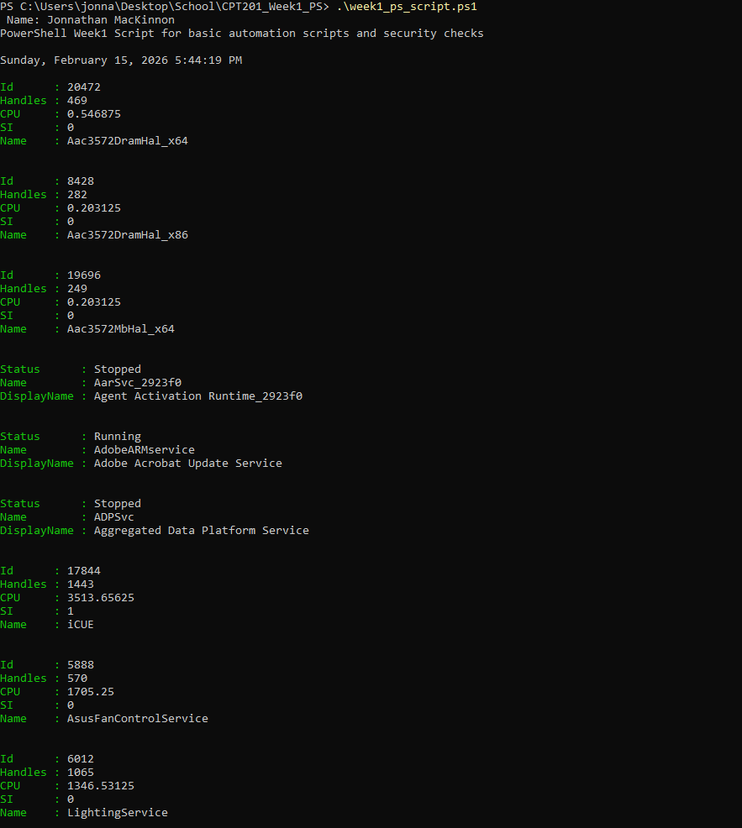
Screenshot:
Screenshot:

Summary:
This activity was a good refresher for me since I have been using PowerShell, CMD, and the terminal regularly for practice and navigation. Even though I was familiar with some of the commands, going back through cmdlets like Get-Date, Get-Process, and Get-Service reminded me how much PowerShell can actually do. I honestly forgot how many built-in cmdlets there are. Running these commands again helped me see how PowerShell can be used not just for basic administration, but also for simple security checks by giving visibility into system activity. Overall, this week helped reinforce the foundational concepts introduced in Chapters 1, 2, and 3.

